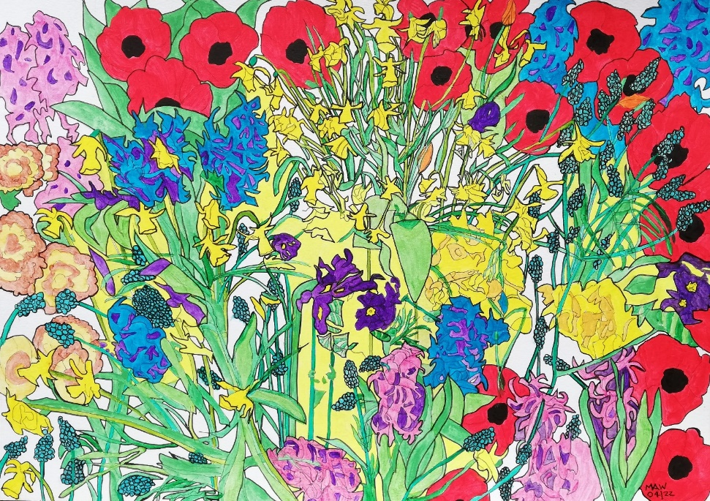

WHERE HAVE ALL THE FLOWERS GONE?

Where have all the flowers gone? Long-time passing.
Where have all the flowers gone? Long time ago.
Where have all the flowers gone? Girls have picked them every one.
When will we ever learn? When will we ever learn?

Where have the young women gone? Long-time passing.
Where have the young women gone? Long time ago.
Where have the young women gone? Taken husbands every one.
When will we ever learn? When will we ever learn?

Where have all the fathers gone? Long-time passing.
Where have all the fathers gone? Long time ago.
Where have all the fathers gone? In uniform, every one.
When will we ever learn? When will we ever learn?

Where have all the mothers gone? Long-time passing.
Where have all the mothers gone? Long time ago.
Where have all the mothers gone? Fled with children every one.
When will we ever learn? When will we ever learn?

Where have all the soldiers gone? Log-time passing.
Where have all the soldiers gone? Long time ago.
Where have all the soldiers gone? Gone to graveyards every one.
When will we ever learn? When will we ever learn?

Where have all the graveyards gone? Long-time passing.
Where have all the graveyards gone? Long time ago.
Where have all the graveyards gone. Full of flowers every one.
When will we ever learn? When will we ever learn?

Where have all the flowers gone, long-time passing.
Where have all the flowers gone? Long time ago.
Where have all the flowers gone? Picked by widows every one.
We must love, not make war. Death enters by our door.
When will we ever learn? When will we ever learn?

Inspired by Pete Seeger

