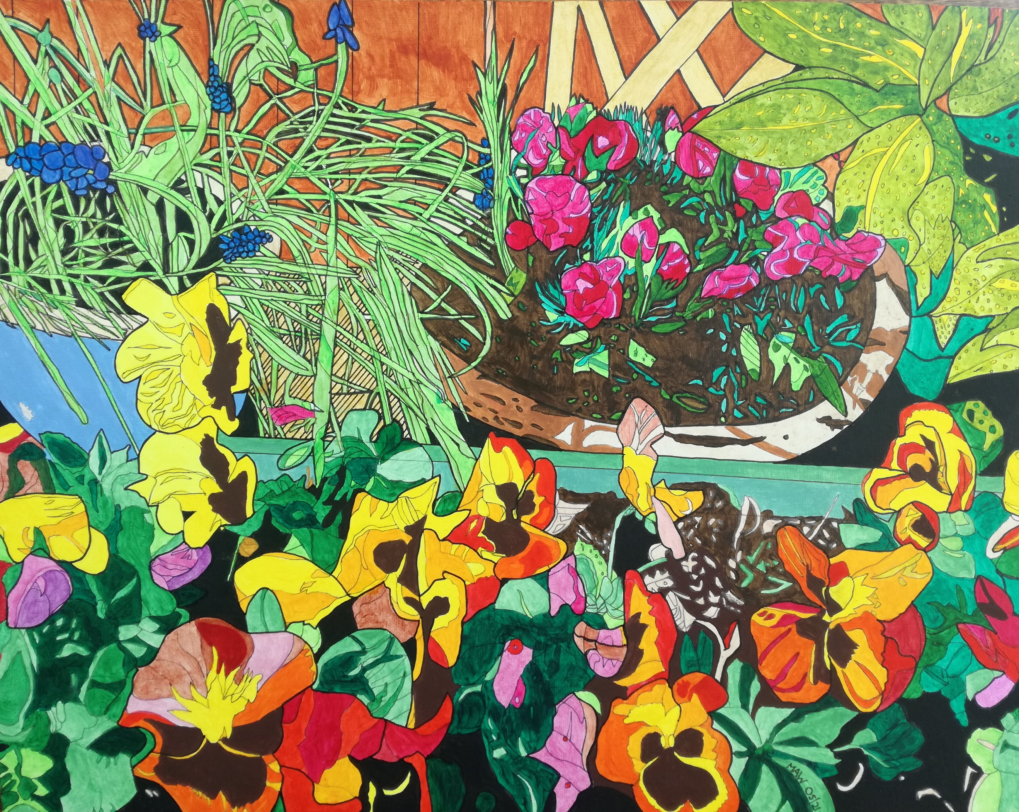

Pensive Pansies

New leaves, tulips, pansies, blossom. Central heating fires less often. Ducklings, cygnets, buzz and spawn. Sunrise yields an earlier dawn.
We’ve seen what governments can do, to help our healthiness renew. And whilst huge swathes of life still die, on richer nations must rely.
Heal humankind, not just at home. Need for vaccines for everyone.

Spool back a year, try to remember, what COP was for, words dismember? Warming warnings for 2030. Continual spewing makes air dirty.
But threats of doom assault the soul, depressed, helpless, no clear goals.
If left with guilt, blame, selfishness, our energy squashed flat with stress.
We’ll never make that quantum leap and get Gaea back on her feet.

So, what can thrill and make us smile, leave us positive and dial a future path of health and hope, above all else to help us cope.
Arrest decline, turn back the clock, reduce the pain and stop the rot.
If rain forests are left to grow. Stop eating meat, reduce the soya feeding chickens, pigs and cow.
In seven years, electricity, decarbonised here, just believe me. Sixty-six per cent, breaking records, for generating renewable efforts.
The signs are there, its not all bad if roofs are solar panel clad. If wind, hydro, waves, molten core are harnessed as we save on power.

But now, big stuff, who has the clout? Politicians, bosses flout because we the consumers rule, become the big fish in the pool.
If we choose products that are clean, assess the true cost of pipe-dreams, buy wisely, local, package friendly, reduce waste, buy necessary.
Recycle, re-use, and re-purpose, make charity shops the preferred locus.
Process rubbish, power source for homes, instead of methane yielding zones.

We’ve been impressed by our young folk. Climate action is no joke and if our politicians laugh, ‘students immature and daft’,
Remember soon that they’ll all vote for futures where they’re safe and ‘woke’,
And grease the political machine to make the future smart and green.
If we’re retired, works at an end, what better message can we send to teens and twenties in our midst, that ‘silver power’ the mill can grist,
And send a message that, ‘til the end, we’ll back them one hundred per cent.
There is no way we’re doom and gloomers. Don’t forget we’re baby boomers!

