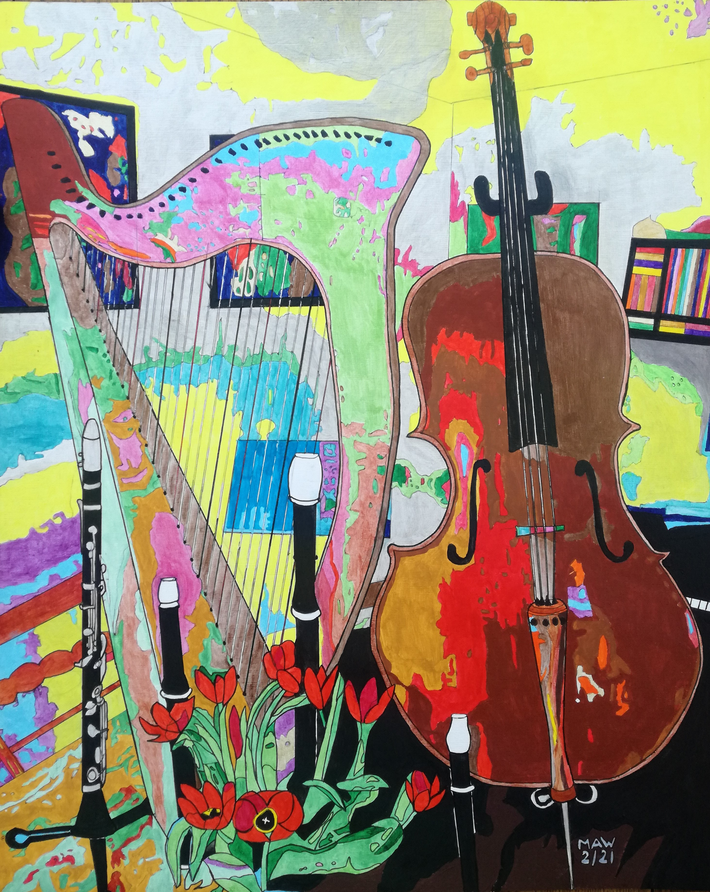

Tuning in to Easing Out

Strains of C, G, D and A, tuning in to longer days, stretch a few more minutes play, a mellow, cello string foray.
Snowdrops herald winter’s end and Nature’s way will warm and bend, a few degrees more shoots will send
With crocus, daffodils and lend an artist’s palette to this drab, cold, frozen new year, colours dab.
Occasionally, sun shines through, piercing grey and chasing blue.
Heavenly strings of Celtic harp softly help reboot the heart, with hopes, dreams, hugs, missed whilst apart.
Clarinet takes up the score, tenor, base and treble force.
Reminds us that our youngsters yearn to jump, run, squeal, energy burn.
With friends they’ve missed whilst kept detached. Screens, imagination catched?
We’re staying home and washing hands, social distancing with masks,
And vaccinations grow apace, leaving variants in disgrace and boost the Nation’s Covid chase.
If only Musk, Bezos, Branson, would pause their space competition, and spend from just last year’s huge gains,
Cast a few billions towards the strained, exhausted eyes and nurses’ pain. Day after day, relentless stress
and holding hands of those near death. So patiently we watch and wait for this third peak to dissipate.
Not to forget all the patients, doctors’, teachers’ dedication all need empathy & care to survive our worst nightmare.
Spring will slowly yield to summer, sons and daughters, grans and mothers sharing, cuddling back together.
Respecting, grieving those that never had the chance to ease their life untimely lost amidst such strife.
Climate change takes a back seat, plastic masks clog up our feet, public transport seems less safe.
We drive up fumes, the young lose faith in 2030’s fading dream of keeping below two degrees.
But dare we hope Boris will lead, Biden commit his country’s greed to build better, building green
And pricing goods so that they glean true costs to nature from our plunder of Earth’s resources, cast asunder.

