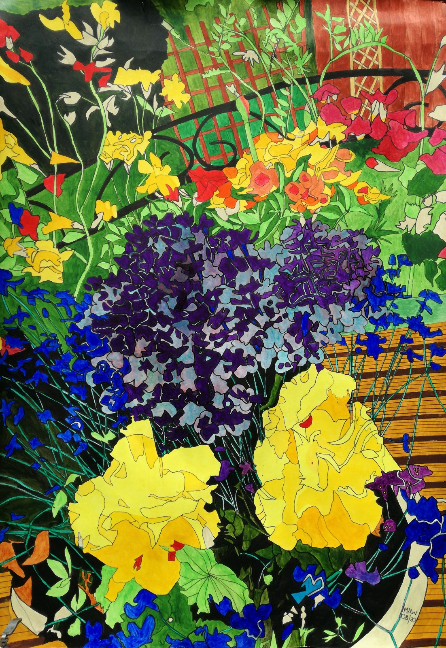

What’s the Story garden glory

Summer snapshot, riot of colour, bowls and planters, troughs, flower fillers.
Baskets, caskets, pots and borders, terraces in floral order.
Hanging feeders, fat ball hoop, peanuts, seeds, bird table food.
Secret passage, hedgerow gap, hedgehog hike to homely gaff.
Maze-like entrance excludes cats, so meat and water can attract
Our spiky friend to rest awhile on leaves and moss, a stately pile.
Lots of blue tits, chaffinch, thrush, blackbirds, goldfinch, collared doves.
Starlings squabble, jackdaws raid, magpies steal and squirrels prey
Upon the nuts and bulbs and buds and sundry others glean their grub.
Pidgeon magistrates in place upon the arch in patient gaze,
Until the sparrows drop their corn, ground evidence where feasting’s born.
Once pecked and swallowed they declare ‘not guilty there’s no wastage there’.
The only creatures I omit are two Koi carp that glide and dip.
Pondlife helps them to sustain each spring when they surface again.

