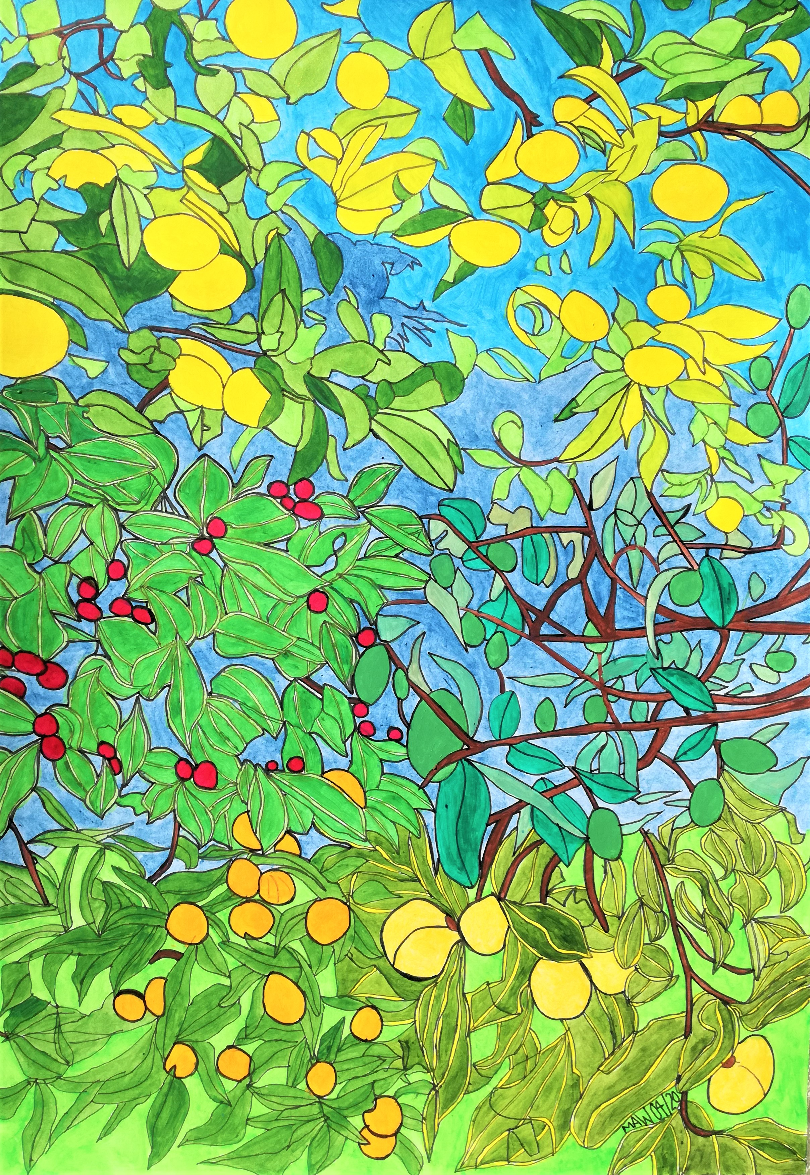

GREEN SHOOTS AND SILVER LININGS

Mount Eden is an autumn dream, grapefruit marmalade to glean,
Cherry guavas and feijoas, persimmon and tangerine.
Pure and wholesome with clean air, no acid rain to growth impair.
Green shoots and silver linings clear from viral degradation here.
Pollution free and traffic light, quiet roads, hardly a flight.
The ether now has copious room for social media and Zoom.
Chat, messages, views in real time; worldwide connections by design.

A slump in growth, lower GDP, falling stocks appeal to me.
How else to slow the widening gap ‘tween rich and starving poor perhaps?
But is this viral pandemonium nature’s way to make change come?
Still, groups gather in the park, escape to baches after dark,
Drink to excess, beat their wives, binge-watch box-sets, pretend lives.
Loss of jobs, investment yields, plough back crops in unpicked fields.
Panic buying, toilet rolls, beans, soap, flour, so empty shelves.

What else could increase family time, home entertainment, a glass of wine.
Just buy essentials, necessities, most luxuries just fail to please.
Emphasising ‘stay at home’, for holidays not far to roam.
Tidy gardens, painting rooms, a ‘teddy bear in windows’ boom.
Running, cycling, walk and greet, a social distance of six feet.
More home cooking, less food waste, slowing down not making haste.
Washing hands and elbow sneeze, kindness, caring, a joy to please.

Invest in health and social care, no beggars, addicts or homeless here.
Develop green technologies and redeploy those job-released.
Buy locally, seasonal food, plastic bad and paper good.
Appreciate the NHS, police, firefighters are the best.
The bigger picture end conflict, wars, prisoner release, love more.
Help refugees to find a home, fight climate change, our earth still warms.
We’re finding we can hope and pray, now make extinction go away.

