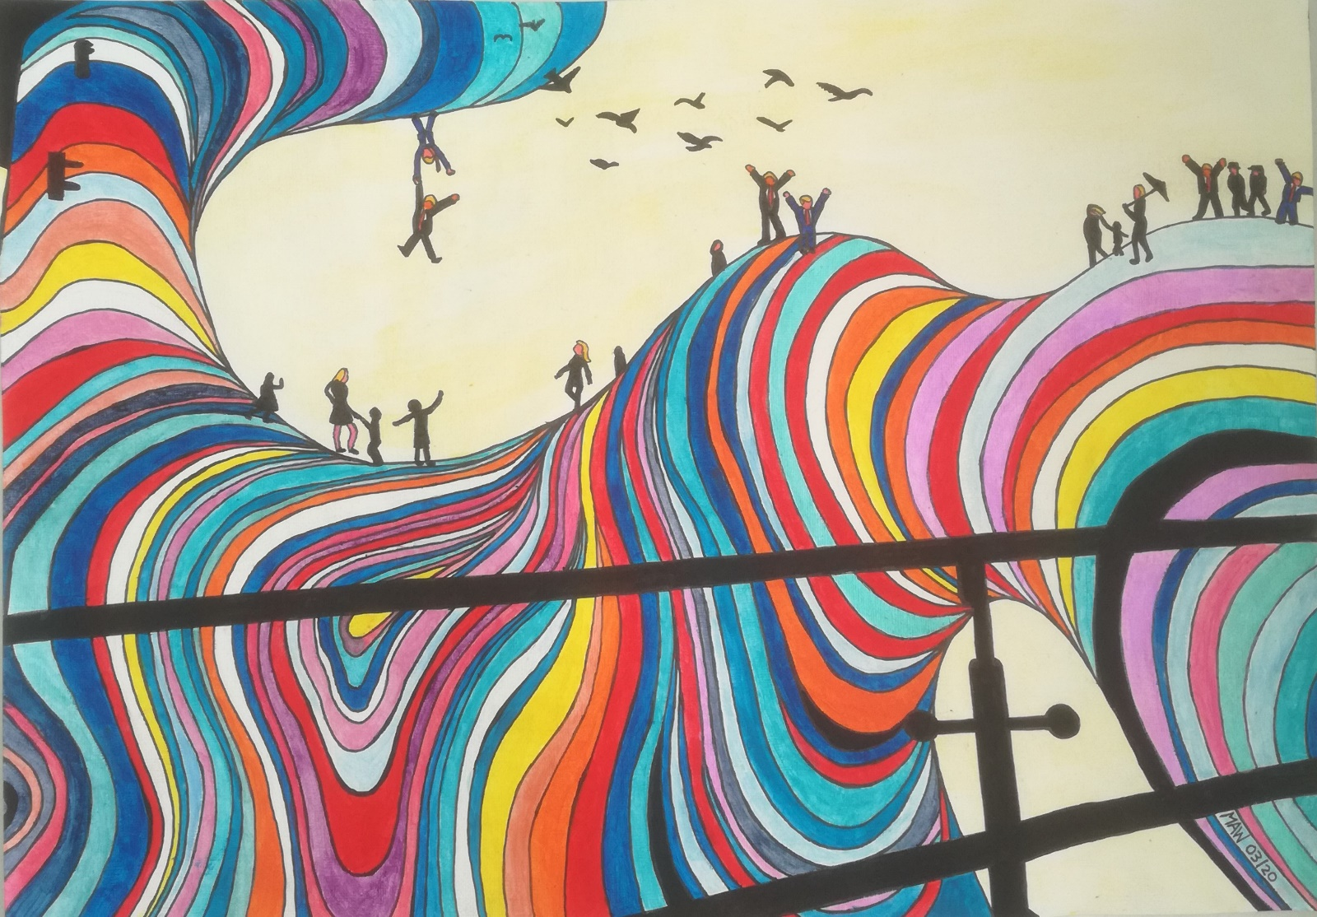

WHAT GOES AROUND COMES AROUND

Behind the barrier I can see painful events that worry me.
What’s seen and done, in this day and age, to peace and need on the world stage?
Communities being pulled apart, countries breaking links and hearts.
Just now we are preoccupied with Coronavirus spreading wide.
Stocks are falling, travel slowed, an isolating two-week mode.
Population takes a hit, use of world’s resources dip,
Pollution eases, producing less, realise what’s left to bless.

Mother Nature will win out and weather storms, winds, floods and drought.
Eventually, the earth will right, giving humans the biggest fright.
Soon we will grab hold and cling to Gaia’s fragile balancing.
The title if this poem is moot, it sums up what is at the root.
It’s hope, and love, respect, concern and passion in our midst still burns.
Short term power and control, dominance, financial goals,
Will be shown for what they are. Greed, lust, insanity laid bare.
We’re still plucking low-hanging fruit but know, deep down, it’s ill-gained loot.

A cable car, to the top job, has winners promise, gift of the gab.
Let politicians, to a man, insult us as long as they can.
But all bad things come to an end, no retribution or revenge
Can bring us back from near the brink, but truth to power, as our arms link.
Open our hearts, kindness to all, show care and comfort when they fall.

