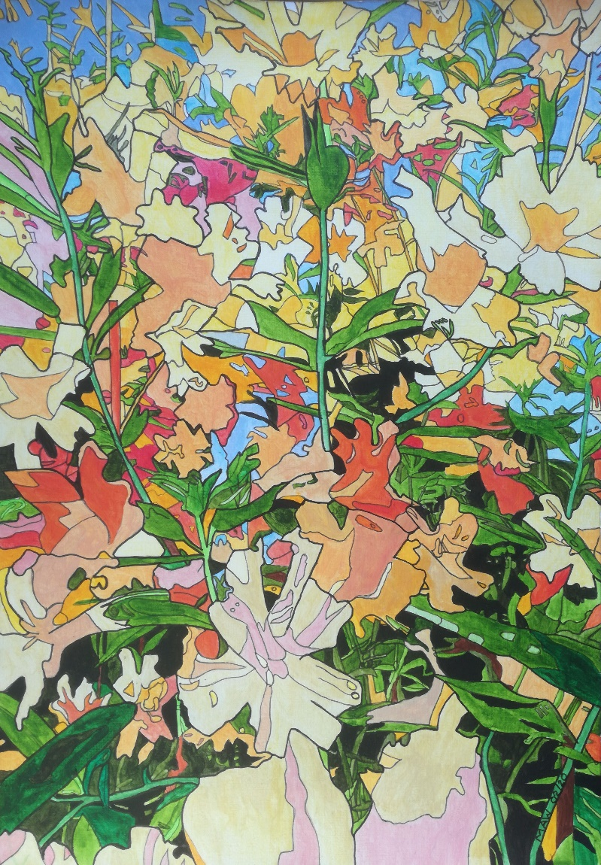

Democratic Floral Magic

Botanic gardens are like zoos, selected flowers on public view,
And even those that grow profuse may be called weeds, if introduced.
Back to nature, out of sync, because for years we’ve stretched the links
To hybrid, force and fertilise and now before our very eyes, genetically modify.
Colours, pest-free, blight resistant, loving shade, drought proof existence.
Air freight cash crops, Valentine’s Day, for a few days then die away.
Organic grown and hydroponic, some plants in space went supersonic.
Permaculture, companion planting, respect the seasons, still basket hanging.
Spray the aphids, kill the slugs, sterilise and treat the mulch.
But there’s ‘an elephant in the room’ and just like that poor creature’s doomed,
Insects and bees are dying out, no pollination – food, there’s nowt.
We will have flowers, silk and crepe but artificial, love to hate.

It often happens as I draw, imagination leaps some more,
And makes connections, rings a bell, finding unusual parallels, like politics and being well.
Those trumpet petals, gaudy, brash, proclaiming honest, self-serving trash.
Birds don’t sing or chirp it seems, but tweet the American dream.
‘Let’s build a wall twixt them and us, and maybe Corona Virus.
World’s scientists must be deranged, talking up this climate change’.
High seas, huge fires, drought, tornadoes are acts of God we all suppose.
The colour scheme comes to our aid with blonde, straw thatch above the face.
A ‘natural’ fake orange tan for the free world’s most powerful man.
Beyond the pond ‘King Boris’ stands and now we’re free from Europe’s bonds,
We soon will hear the rallying cry, lest Scotland, Wales, N. Ireland fly.
Stiff upper lip’s the way to go, with HS2 and no Heathrow.
The phrase that’s coming, sole refrain, ‘Let’s make England great again’.

