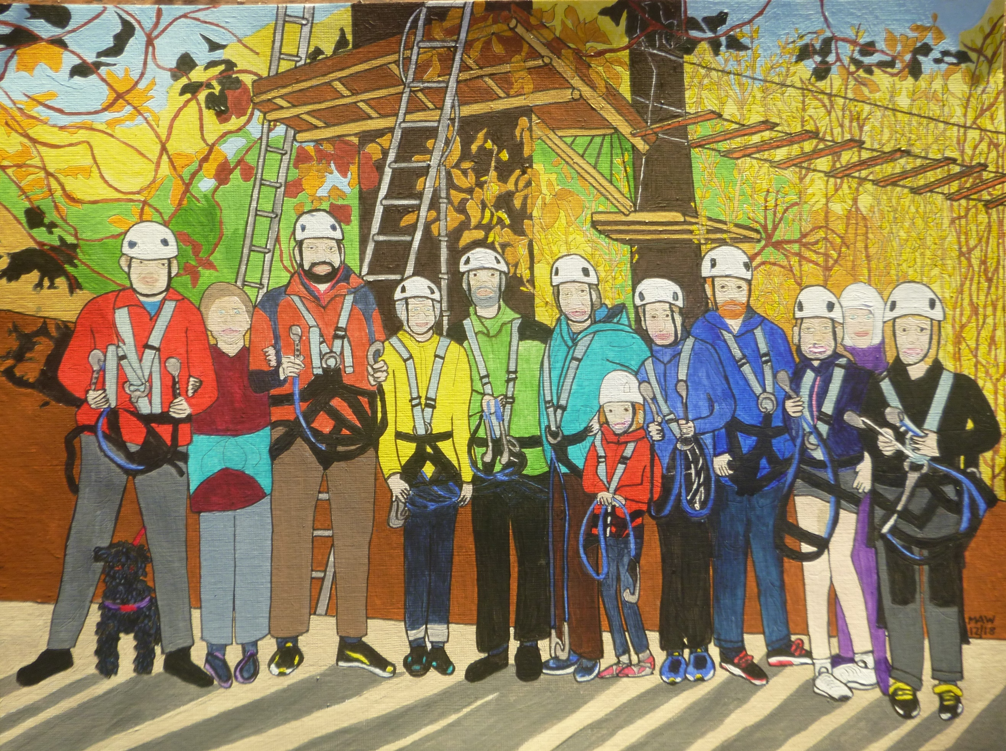

Re-inspiring

2011 felt just like heaven, to be retired and so inspired
To seek the joy that freedom gives and not obey employer’s whims.
Twenty-five years of property and fifteen years just being me,
Sharing, listening, being there, gently respecting souls laid bare.

A dream comes true as we book-end our working lives to serve and spend
More time in Africa in roles, training in health jobs bestowed.
Back home with family for a time before our Quaker faith did find
A place for us in Aotearoa midst Auckland’s warm and sunny aura.

Since then we really are retired and so click in when upward fired
To U3A, walks, films, OXFAM, joyfully joining family plans.
There have been scares and thinning bones but never much reason to moan.
We love being challenged and miss the heat, hence our India Railways feat,
To see both school and home for Liz for sixteen years she learnt and lived.

It’s great when grandchildren enthuse and second childhood jinks amuse.
So special when we’re altogether on bikes, in trees, in clement weather.
We’re lucky, never wish to miss a moment of our wedded bliss.
Same vision, spirit, heart and soul to seek and share our future goals.
Adventure, travel, peace and fun with open mind our chance will come
To take us on in older age. Our love for life will never fade.

So, New Year will soon be here. We hope you’ll warm with Season’s cheer
And can look forth, though skies be dull, to drink from cups always half-full.

