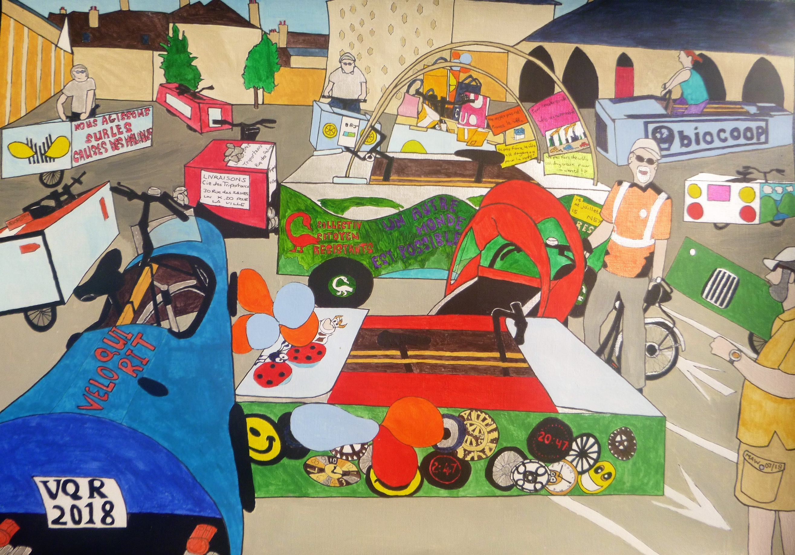
Vélos vivants
En Jura, Lens-le-Saunier, we chanced upon, one Saturday,
Boxed protests, gleaned from bike shop trash,
Being fixed for two-wheeled cycle dash.
Promoting healthy, smart lifestyles.
Alternative pollute-free miles,
Or, strictly speaking, like the litre,
Fresh air, smoke-free kilometres.
Each box, unique design and posters
From worthy donors, shops and hosters.
Biocoop, Vélo Qui Rit, Laughing Cow inspired soft cheese.
Santé solidarité sur les causes des maladies.
Another world is possible and global warming reversal.
‘Sit here on my three-seater trike, process in style, no need to hike.
This tricycle takes pensioners out and you’re the nearest folk about’.
All around the town, stopped all the traffic,
Waving, laughing, mood ecstatic.
Take trains and buses, ride and walk.
Then exercise your right to talk.

