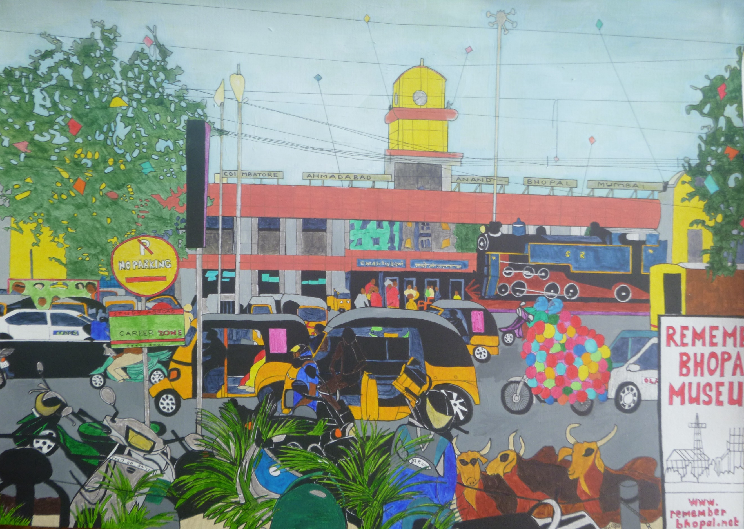

INDIA SELFIE

Festive season, family fun. Flew to Mumbai seeking sun.
Washing-festooned balconies, slums, cramped blocks and lack of trees.
Three-day train, A.C. coupé, vegetarian café.
Dosa, rice, spiced veg., idli, pakora, nan, onion bhaji,
Masala chai, tomato soup, mineral water sold en route.
Swampy lakes, heron, egrets. Rocks and dust, dry river beds.
Nostalgia trip, go back in time, Tamil Nadu’s cooler clime.
Monkey familied High School gate, unchanged, now an orphanage.
Moved to Ooty, ratchet track. Photos, stories brought all back.

Ahmadabad, fireworks, kite race. Gandhi’s ashram, peace and faith.
Dodging plastic, sleeping dogs, pollution and gaudy shops.
Beeping rickshaws, traffic battle, ballooned bike, avoiding cattle.
Moghul, Jain, Hindu and mosque, mystery of temple gods.
Salt-pile, concrete spinning wheel. Anand, garlands, curry, dahl.
Hospital reincarnating, college, school, industrial training.

Bhopal’s thirty-year old blight. Union Carbide’s desolate site.
Friendly meeting, re-built church, vistas from a hill-top perch.
Punjab Mail, skyscraped Mumbai, metro, tuk-tuk, back to fly.
Airport meal with last rupees, but our bill did cash exceed.
Pay by card? No one to lend. Found coin on table, perfect end.

