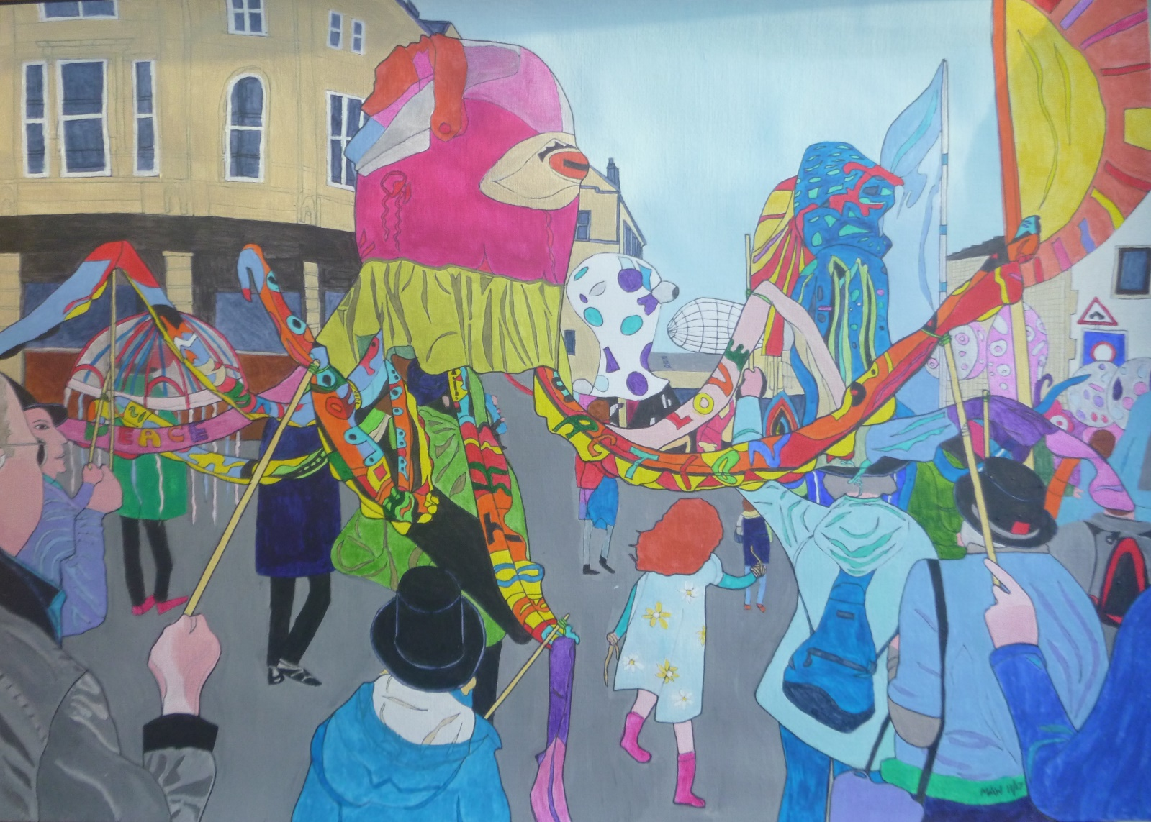

SEA OF DREAMS

Sea of Dreams, groups and themes, Skipton’s two-year puppet scenes.
Community collective cool, creative joy, home, church and school.
Quaker quaintness embraced the fun and we reached out, forgive the pun.
An octopus in lurid pink, eight legs, kaleidoscopic kinks.
Hoolahoops and chicken wire, bubble-pack, felt, glue helped gyre.
Swim noodles, sewing, stick-on words, football eyes, green curtain skirt.
All held up by a clothes prop. Canes and bungees helped wobble and flop.
Top hat mover, stick-held legs. Umbrella jellyfish erect.
Dancing flowers whirl through the town to nautical-costumed renown.
Excitedly we’d whoosh and swim, twirling with tentacled vim.
We hoped our Quaker-hatted Friends helped spread a message to this end.
Bring peace and love, act true and fair in simple deeds and equal care.
Repair, re-use, recycle please. Don’t dump plastics in our seas.
For all processing fishy friends, squid, seahorses and sharks don’t rend
Homeless with warm, rising seas. Let’s keep below that two degrees.

