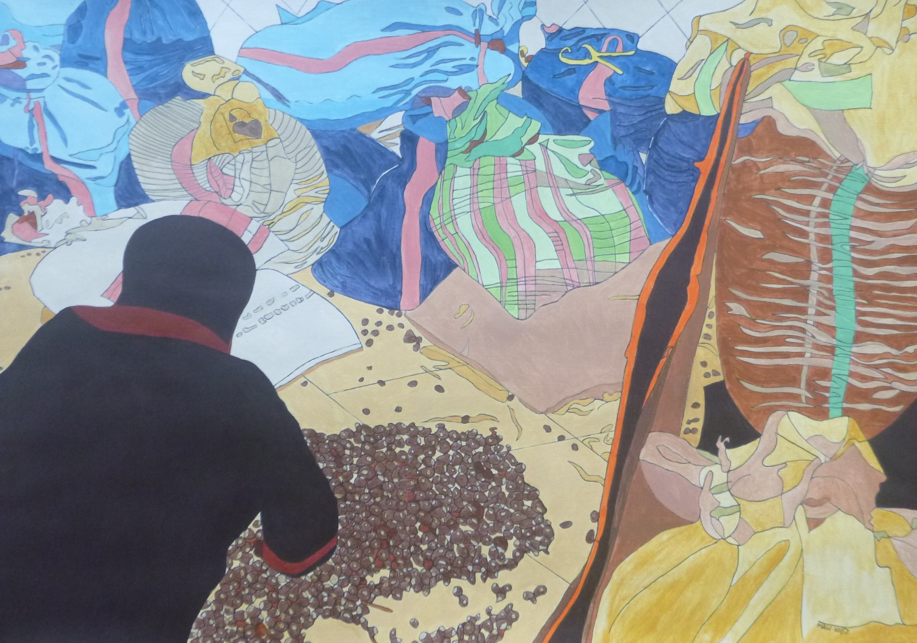

MOROCCO MUSING

North Africa, west of the Nile, Morocco’s prehistoric guile
Forged trade beyond Sahara’s stretch to Fez, Rabat and Marrakesh.
Dry, dusty plains, steep, giving sway, High Atlas, deep-cut motorway.
Passed camels, donkeys, olive groves, well-fed, screened bananas grow.
Through gated wall to Taroudant. Clay-formed city, shaded, cramped.
Kasbah, souks, horse-drawn caleche. Five-fold calls from minarets.
Our ‘troupe des chanteurs’ soon encamp. Tagine-fed, early roof top chants.

Berber hillside, pisé homes with power, cable, mobile phones.
In semi-desert, argan trees, deep-rooted, fruited, with small leaves.
Once goats climbed, ate fleshy fruit and undigested nuts were pooped.
Collected, washed, cracked, kernels crushed, stone-ground, yielding oil from mush.
Now hand-picked, de-pulped when dry, ground, pressed, filtered oil refined.
Bottle, label exporting. Hair and body nourishing.
Hot mint tea and flatbread cooked on clay oven, fuelled with wood.
Local clay for pots and pipes, thrown, shaped, dried and then kiln-fired.
Labour, by hand, fills square form, making tiles floors to adorn.

Smells and sunshine, smiles and care, and got back by Ryanair.

