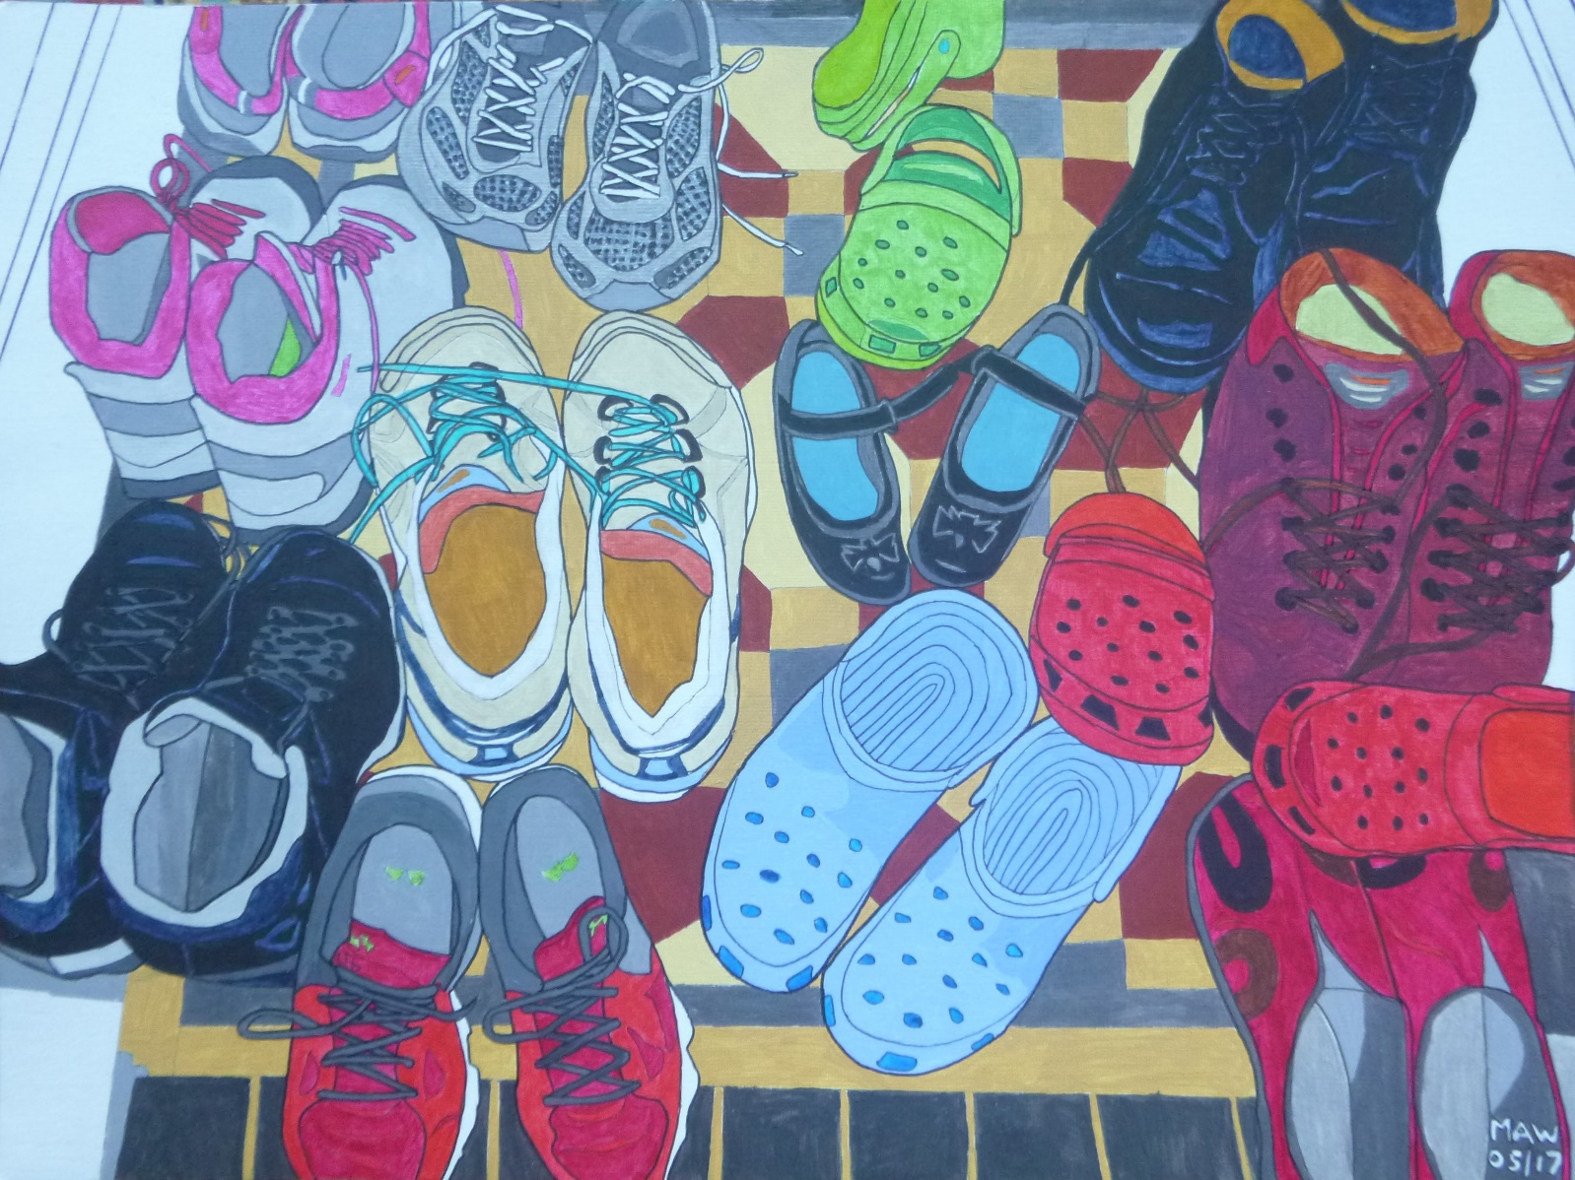

FAMILY FEET
Blue insole, black patent leather, bow-adorned to give toes pleasure.
Wear outside school comfort zone, dancing, jumping, scooting home.
Slip-on crocs, red, blue and green, for cool and casual indoor scene.
When back-strapped, wear on your bike. Complement clothes that you like.
Trainers – football, park run, climb, snazzy red, blue laced design.
Gripping sole and ankle pad, unisex for lass and lad.
Breathable, wash in machine, help fulfil that keep-fit dream.
High-end fashion, bargain rail. Strong black boot wear, practical.
Serious hiking, fabric, leather, keep feet dry in soggy weather.
Lace up, stride out, rough terrain, lasting years, protect from pain.
All this footwear, shoes-off rule, congregates in vestibule.
Welsh coast cottage, Anglesey, hired by Waters family.
Some shod feet go walkabout, dramatic moves - I’m in no doubt.
Purple sneakers, two pairs blue, one laced pink – the Story crew.
Include slimline, techno-whites, skilled on salsa-tango nights.

