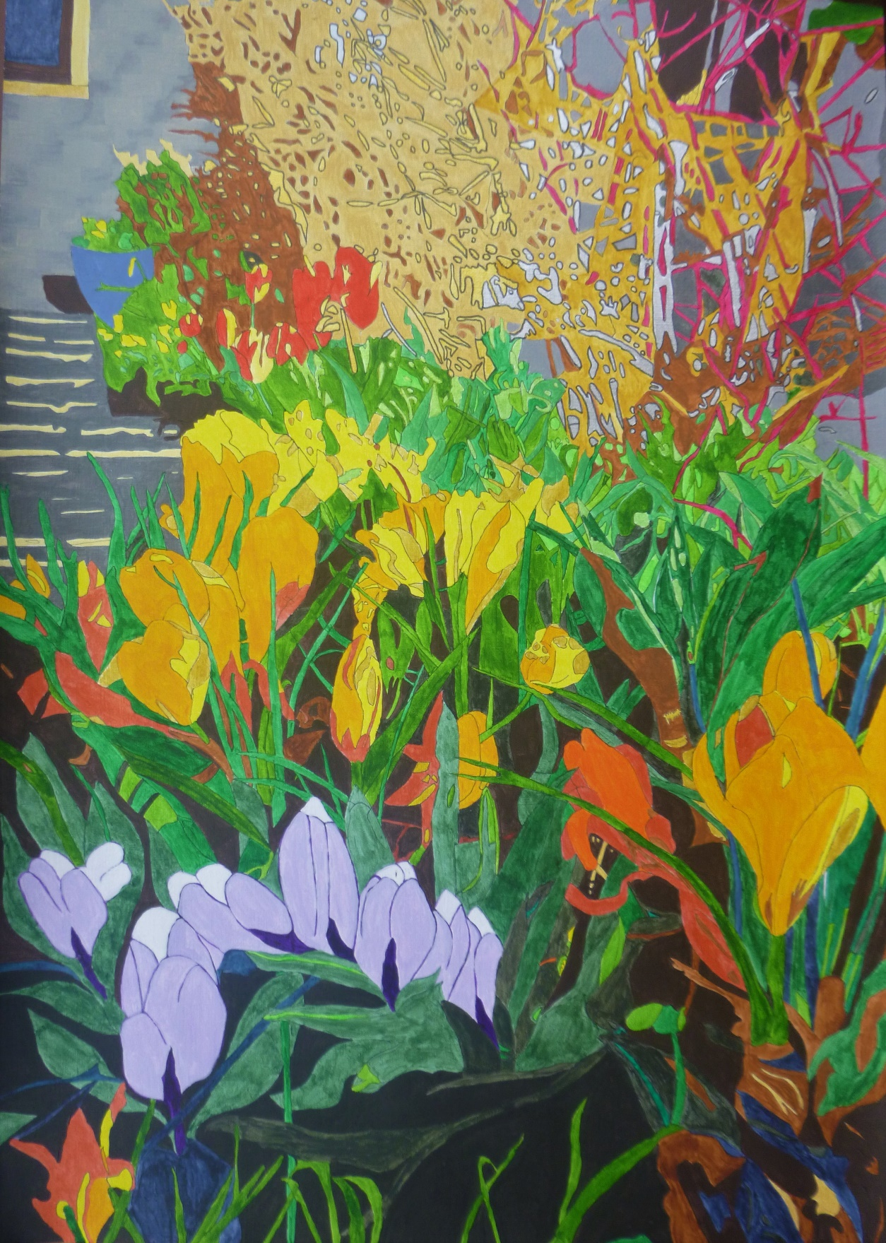

CROCUS FOCUS
Gazing through the portal at life’s journey passed before. Abundant growth of twig and branch spawned from a neural core.
Synaptic sap impulsively connects from root to leaf. Blood red with gold and silver strands with teaching by degrees.
The bedrock is one’s ancestry, soil cover - family. Promoting green profusion yielding faith and self-belief.
Impulsive, ruddy passions burst with love and tears of rain. Yet early, deadly blue sneaks in a taste of loss and pain.
Life blossoms, sourced by far-off lands with melded visions gird. Sunshine yellows, orange joys of children, home and work.
Changed directions, russet, ochre, indigo, dark green. New careers as off-shoots spread and realise their dreams.
Prodigious growth in lilac, purple, hides decay tinged brown. As light and dark provide the spark for helping others now.
Retiring shades ’neath emerald blades with vibrant flowers in store. Until a step beyond the bed to memoir’s open door.

