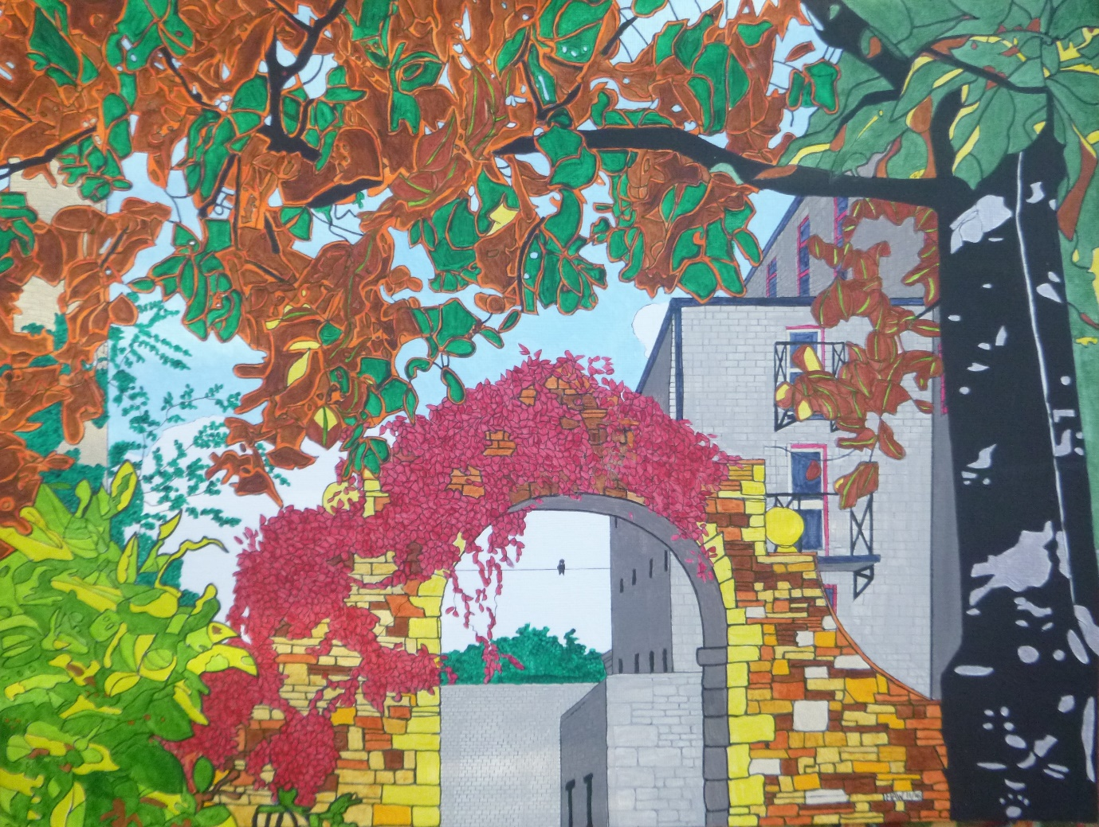

SPRING AUTUMNAL

Backing time, light morns, dark eve’s; buds and blossom, bare-leafed trees,
Bees, flies, wasps, ants, slugs and snails; cat hair, dog coats, squirrel tails.
Blue-tit nest and fledging chicks; murmurations, sky exits.
Flowers and pollen, scents and fruits; poppies, pressed flowers, laureled hoops.

Chilled juice, ice-cubed, croissant, smoothies; picnic, sun-bed, barbecuing.
Easter eggs, cream scones and jam; porridge, marmite toast and ham.
Salads, onion, radish, cress, tomato, pepper, neatly dressed.
Chunky soups, some creamy, spiced, warm the heart with crouton bites.

Shorts and sandals, skimpy tops; scarves and jumpers, boots and socks.
Hanging baskets, cutting hedges, pruning, plant bulbs, lifting veggies.
Country hikes and holidays; concerts, film nights, take-aways.
Cycling, swimming, climbing wall; blue sky greys and snowflakes fall.

