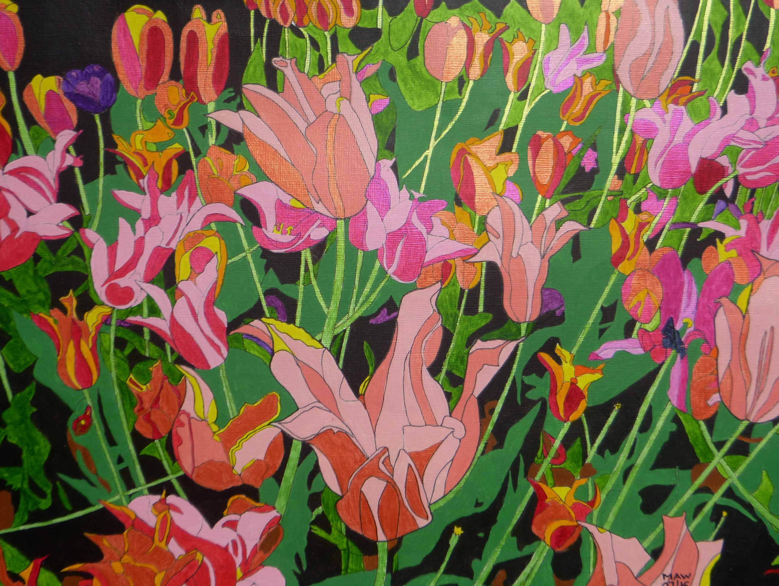
BABY BOOM TO TULIP BLOOM

A Kenyan paper licence is proof VSOs wed.
And cotton nappies on the line – we don’t just sleep in bed.
Work, leather shoes and linen shirt, from York to Preston bound.
With Anna joining Barnaby with burping, chuckling sounds.

The ‘Kingdom of the Sky’, Lesotho’s poor and woodless slopes.
Charcoal irons, Mohair wool, housing manager coped.
Via pyramids, bronzed by the sun, school starters just in time.
Start to adapt to wind and rain in Trawden’s unique clime.

We toasted our adventures in glazed pottery sublime.
Like Tintin we drove Deux Chevaux and Lomax, hers and mine.
Steel cabinet for documents was Mike’s ‘romantic’ gift.
Silk scarf, flying, cycling on, Liz didn’t need a lift.

With Masters we both laced our skills, H.V. and counsellor.
No to Indian ivory, ice-crystalled, China’s Wall.
Our silver Tanzania and B.&A to univ’s five.
Then Quaker wed, in Birmingham and Bangor homes reside.

Now Skipton based and down-sized, there’s still room for all our kin.
Adam, Robin, Leo, Grace and Hazel all fit in.
Retired, on VSO again to ‘Pearl of Africa’.
Then bus passes and hybrid cars help us go near and far.

No coral reefs, but beautiful NZ fulfils our year.
With ruby ring and forty years of love, we’re in Grasmere.
From ‘baby-boom’ to tulip blooms, so many tales untold.
But then there’s more exciting years as we both go for gold.

