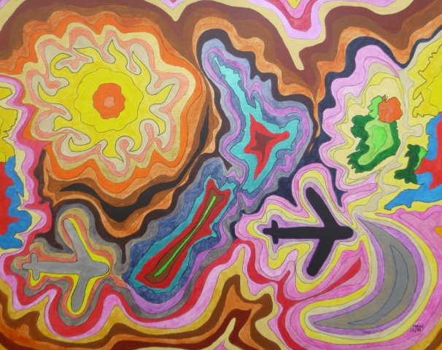

THERE AND BACK AGAIN

Kia ora’s a greeting to welcome the day, a villa’s an old house, wood, fretwork and bays.
Jandals are footwear that we call flip-flops. An op-shop is just like a charity shop.
Gumboot is similar to our builders’ tea. Plunkets help mums just like our H.Vs.

An aerial runway is a flying fox. Swimming costumes and trunks are always called togs.
A chuck is a hen, W.O.F. an M.O.T. Munted is broken and pluty, wealthy.
A run-off’s a paddock and lizards are skinks. Tramping is hiking or rambling I think.

A batch is a bothy, small house incomplete. Manchester are towels, pillowcases and sheets.
Chippies are crisps and lollies are sweets. Adventures abroad are known as O.E.
Solving a crime is a resolution. Capping confers degree graduation.

Netball’s Sliver Ferns, basketball is Tall Blacks, rugby’s All Blacks but Black Ferns do not lack.
Black Sticks are hockey, Ice Blacks are on ice, Black Caps are cricket, Black Fins save lives.
Flag’s Union Jack and four, red stars on blue. The silver/black fern’s referendum is due.

Haka’s a war dance, aroha is love, tena koutou a greeting for two or above.
Waka’s a long ocean-going canoe. Pakehas from Europe much like most of you.
For hongi press noses, earth-cook is hangi. Marae is a courtyard or House Maori.

Koha’s a gift, hui’s when all meet. Kick off those shoes and enjoy your bare feet.
Moko’s a tattoo, protest march hikoi. Mokopuna’s a grandchild either girl or boy.
Iwi’s the tribe and goodbye’s haere ra, to New Zealand or rather Aotearoa.

