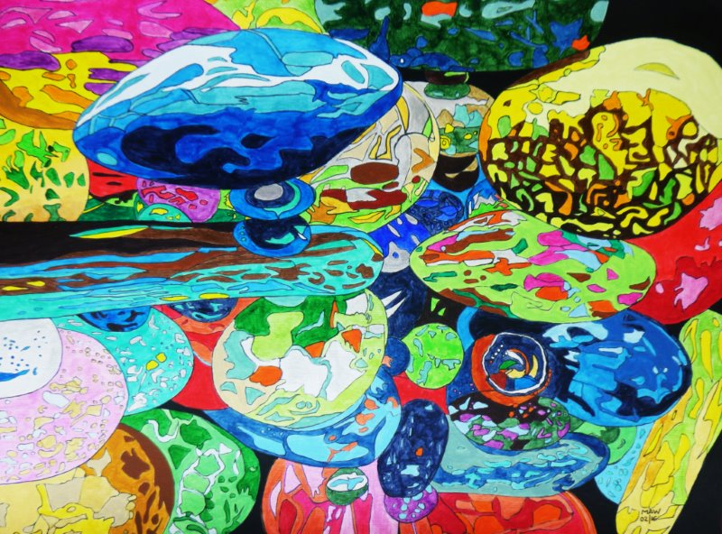
DID YOU EVER?
Botanic Gardens. Marbled globes, stacked and rolled,
shiny colours, dark and bold, triggered memories of old.
Rest and balance, style and poise.
Kaleidoscope of childhood joys.

Did you ever play with marbles , during break-time, with your mate
and lost that bobby-dazzler, blue and yellow met its fate?
Down the channel, round the tree root, earth compacted by small feet.
Spinning, swerving, bouncing, curving. Try to win, but then defeat.

Did you ever sleep on camp-beds, afternoon, post meal-time snooze?
Drink milk from tiny bottles, either that or orange juice?
Have a wonderful head-teacher? Nature walks and puppet shows.
Fall in love with your Miss Charlesworth? Married, South Africa she goes.

Spend your money at the tuck shop, gob-stoppers and wagon wheels?
Sherbet fountains, liquorice whorls, don’t spoil school dinner meals?
Spuds and beans, ham and greens, turnip, spam, sago or rice.
Stir in jam, disgusting pink. School nurse checking height, and lice.

Did you ever have an accident, squirming, hand up once again?
Just wait until the bell rings, her repetitive refrain.
Sent home shame-faced, head-bent disgraced, seeking comfort from my stain.
Mother’s temper, Grandma’s disdain, bath and bed to nurse my pain.

Then once Father, working harder, fetched from school on motorbike.
In his lap, holding fast, red and chrome soon brought me home.
Ran to Mum, tripped-up run, cut my knee, tears, can’t see.
Cleaned and soothed, felt a fool.

Did you ever jump off haystacks, build a den up in a tree?
Prop that bike against the wall, pushed, fell ten times then cycled free?
Roller skated and then snaked in line behind a speeding trike?
Built a go cart, greased and painted, fitted ‘cow horns’ on your bike?

Did you ever try at sports but always failed to make the grade?
Were you ever chosen last when teams were picked or new plans made?
Did you play in schools cup-final, level score near whistle time?
Goalie booted, ball rebounded off your knee and crossed the line.

Better leave this reverie, nineteen exhibits to see.
Giant Foxglove, monkey learning, Madame Heron, bronzed, sat yearning.
Tent and boat ceramic glazed and a pineapple of spades.
Fountain stepping top to toe, birds cut out and free to go.

Did you ever?

