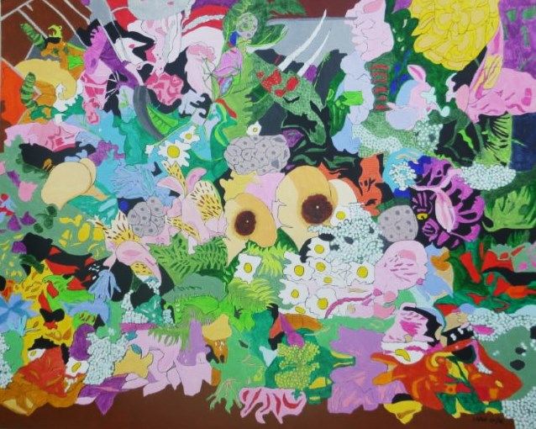
WHERE HAVE ALL THE FLOWERS GONE?
Flowers for peace, flowers for love, grouped in posies, bunches, sprays.
Wreaths and garlands, tributes weave; weddings, funerals, thank-you ‘says’.
Bowered bravery and clumped courage. Shock from an untimely death,
Pavement decked, railing bound, anonymous respect.

Brown for mud and red for gore; coloured flags engaged in war.
Quakers, pacifists, Maori,more, conscientious objectors.
Some faced the conflict but took a stance, by serving the Friends Ambulance.
Some fled, shell-shocked, unravelled, worn, court-martialled, firing squad at dawn.

I’ll take you back one-hundred years, Christmas 1915.
C.Os, prisoners languished in Mount Eden’s cell-locked dreams.
Peaceful men, through faith not fear, would not bear arms to kill and maim.
Confined, taunted, months and years but one small gift remains.

Every Christmas since that date, posies sent for each inmate.
A sign of love, non-violence, peace, until parole, time-served release.
This year, centenary of Auckland Quakers’ gift.
Every soul left wasting there received a floral lift.
Green grass, bright sun, fresh air, blue sky, symbolised in flowers for
Three times one hundred, fifty more, in concrete, tube-lit sty.

