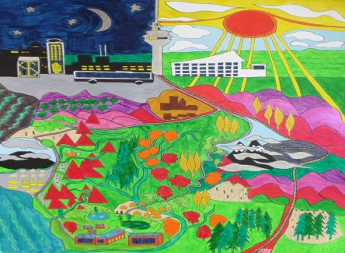
WANGANUI WELCOME
Breasting hills, curved descent,
Smooth and easy, somnolent.
Spiral railway, poplar gold.
Ruapehu clouds on snow.
Slatted beams, palm-ferned scenes,
Muddy landslide, worn out dreams,
Winding, falling, journey spent.
Wangaui Settlement.

Greeting, meeting, nature's grove,
Peace-walled silence, smiles and love.
Inreach, outreach, outward bounded.
Spirit centred, George Fox founded.
Maori legends, deep respect.
Grow together, nature decked.

Oil refined, eczema risk.
Typhoon damage, soil sun-kissed.
Winding, rising, swollen courses.
Pyramidhills worn to gorges.
Coastal heaven, tarmac ribbon,
Limestone caves, streams sea-bidden.
Miles and miles of 'wowing' views.
Taranaki, shrouded, looms.
Dripping tunnels all rock-hewn.
Knife-edged ridges, silt-full rivers,
Sheer side wooded, driftwood littered,
Sunset glory, seated sorely,
Naked bus ends nine hour story.

