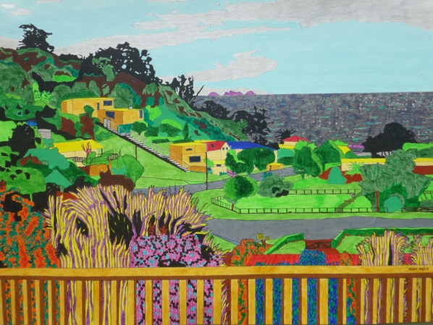
WAIHEKI BEE
Ferry free, Waiheke, working bee.
Lands, swarms, climbs up high,
Tree-top haven, 'twixt sea and sky.
What's to do in gardens fair?
Plant, renew and lay weeds bare.
Friends' House decking needs TLC,
Crowbar rotting woodwork free.
Step up and fill that trailer Michael.
Take to the dump and there recycle.
In future weeks, bearers preserved,
Will nail new timbers, well deserved.
New flowers and shrubs prepare to bed,
Dig, water, compost, richly fed.
Cut back flax where it sways,
Stroking vehicles' upward way.
Fruitless trees, lacking girth,
Felled to resting place on earth.
Softly bedded in the mud.
There to home fungi and bugs.
Around the table, hunger's fed.
'Devour the soup, the veg., the bread,
Unmentionables that vegans dread.
When day is done and all replete,
Read, scrabble and rest backs and feet.
Night falls, stars sparkle, slow to still,
Just like a hive the bunkroom fills.
Take in the view, the waves, the trees,
Thankful that the sun was pleased,
To shine upon us morn' 'til eve.
Busy bees prepare to leave,
Wing home from verdant, tended spaces.
Buzzing joy and smiling faces.

