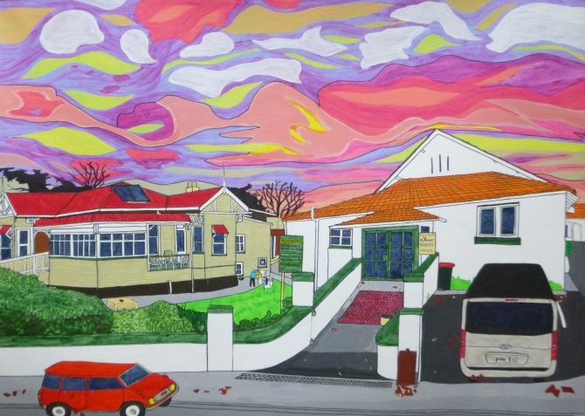
ACTIVE AUGUST
These words will help you to make sense
Of Quaker Friends in Residence.
Caretaking of Mount Eden Centre,
Greeting, guesting, fix and mentor.
Groups communing here and there,
Worship, seeking, truth aware.
Much tea drinking, shared meal eats,
Discerned silence, Minute feats.
Deep discussions, spirit lead,
Calm the soul and tax the head.
'Xero' software reconciling
All donations, daily spending.
Emails, letters, texts and 'phone,
Washing, cleaning, hearth and home.
Open, closing, on-off switching,
Mowing, pruning, loads of washing.
Toilet fixing, bell-push hopping,
Souping, baking, fruit preserving.
Bulb exchanging, see the light.
Locking-up, secure the night.
Maintain wind and watertight.
Next repair, ban rotted wood,
Decorate from fair to good.
Time-out? Often. Art and books,
Knitting, films and TV looks.
Cycling free, zephyr-sped,
Loaned by Margaret and Ted.
So what's left? Land on our feet,
Sleep content and life replete.
Amazingly it just gets better,
Family, global jet-setters.
Grandchildren to play and hug.
Catch Antipodean bug.

