POWER 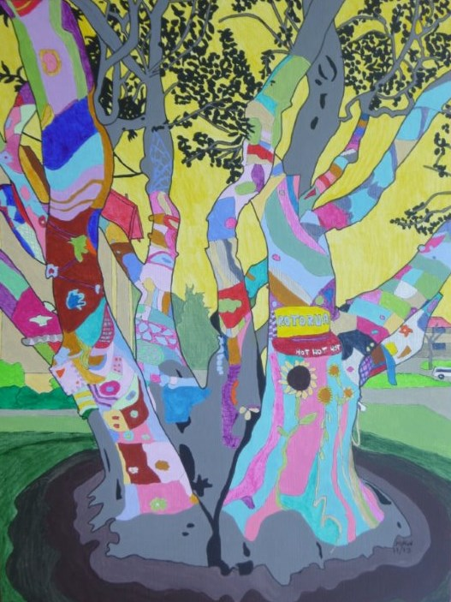 KNITTING
ATOM
HYDROGEN
CHEMICAL BIOLOGICAL
CARPET CLUSTER
DIRTY INCENDIARY
SUICIDE
PARCEL
NAIL LETTER
FIRE SMOKE SEX
FLOUR WATER PHOTO
YARN . . . .

