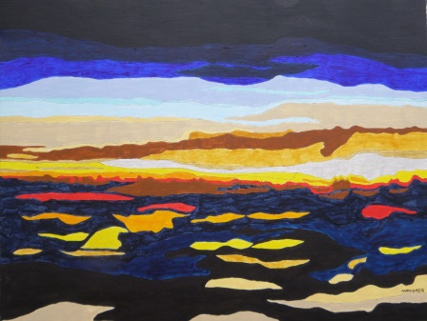

CLOUD SUNRISE OVER K.L.

Air-tossed cloud blanket, dark and serene

Until K.L. sunrise bleeds through my dream.

Commerce and traffic, houses view the sea.

Kia ora welcomes. Mount Eden supreme.

Lawns, flowers, low bowers and octopus trees.

Amble in the sunshine, in parks take my ease.

No-doers, song crooners, beseeching me.

Deep silence, love, action and friends drinking tea.

